TECh Upload
NEw IT Alliance

NEW and Upcoming Events  Nov 17: WIT@Work Breakfast Series – Crash Course in Design Thinking  Dec 05: Amplify – Are you reading the label from inside the jar?  Dec 07: New North Summit  Jan 26: WIT@Work Breakfast Series  Learn more at newitalliance.com/events  NEW it alliance News  Future Newsletters  Submit any content that you would like to have featured in a future newsletter to newitalliance@gmail.com by the 20th of each month.  Any events you would like us to help promote, complete our “register your event”(link to events page) form located on our events tab.  Welcoming our new members this month  This month, we welcome Plexus, Festival Foods, KI and Skyline as our newest Alliance member, joining our growing list of members in higher education.  Thank you to all the volunteers  NEW IT Alliance would like to thank all the volunteers that took the time out of their day to contribute to something so great. Your help during the NEW Connect IT Career Fair was greatly appreciated and we look forward to a successful event next year!  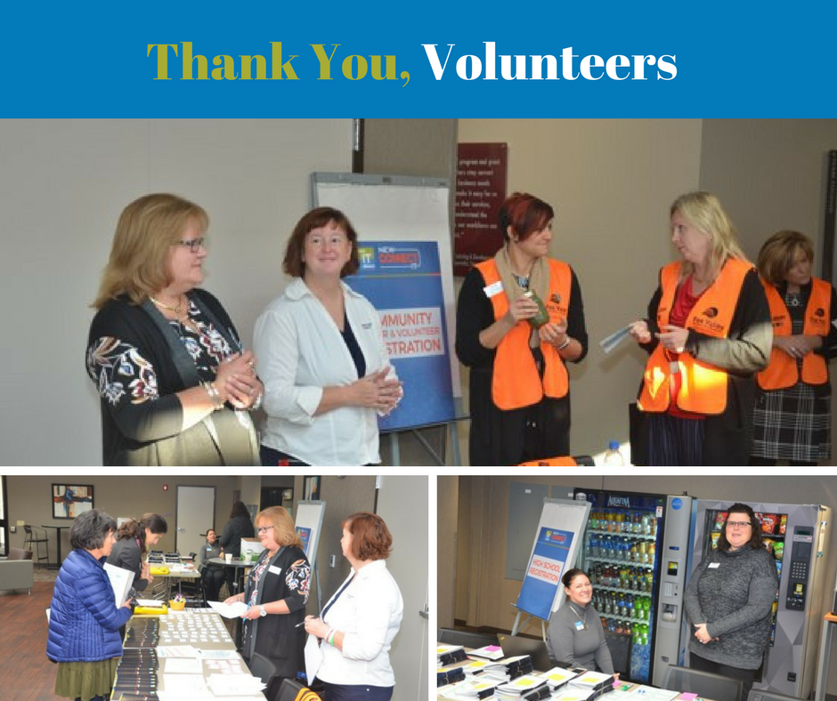  Regional News  GIRLS WHO CODE CLUB  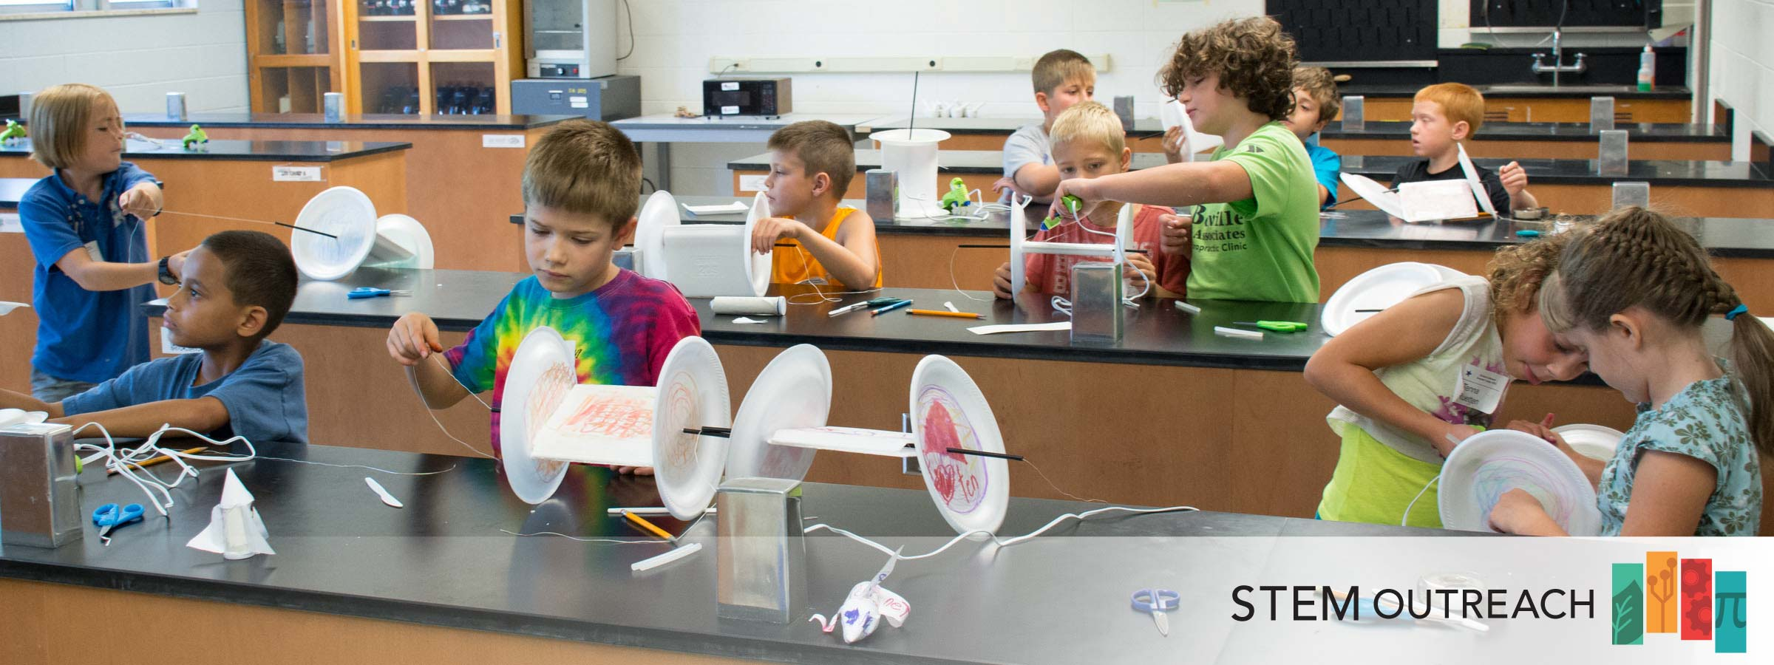  With the help of a mentor from WIT Wisconsin, UW-Oshkosh STEM Outreach is preparing for a second meeting of the Girls Who Code Club at Webster Stanley Middle School. STEM Outreach recruited 6th - 8th grade girls during lunch on November 7. Girls received information about Girls Who Code to share with their families then joined the mentor to try coding Ozobots. Thirty girls signed up to get more information and ten girls have registered to attend club meetings. Meetings will be led by the WIT Wisconsin mentor and two UW Oshkosh students on Mondays, 4 - 5:30 at Webster Stanley MS, November - March 2018.  gBETA  NEW IT Alliance would like to welcome gBETA to the region. gBETA is a free accelerator for early-stage startups with local roots. The gBETA program provides participants with intensive and individualized coaching and access to gener8tor’s national network of mentors, potential customers, corporate partners and investors. The program is designed to help startups gain early customer traction on their product or idea, and establish metrics that make them competitive applicants for full-time accelerators or angel investment. Through gBETA, Microsoft and gener8tor hope to spark technology, drive local economic growth, and spur innovation in various industries, including traditional Northeast sectors such as paper, agriculture, and manufacturing. | NEW IT Alliance News  NEW Connect IT career fair  With the conclusion of the inaugural NEW Connect IT Career Fair, we are happy to say that it was an outstanding success! With a total of 33 booths and over 300 high school students, college students and community members attending the career fair. All of whom were there to learn about opportunities that IT companies in Northeastern Wisconsin could offer. Thank you everyone who came and contributed to this wonderful event. We look forward to seeing everyone next year for an even better career fair!  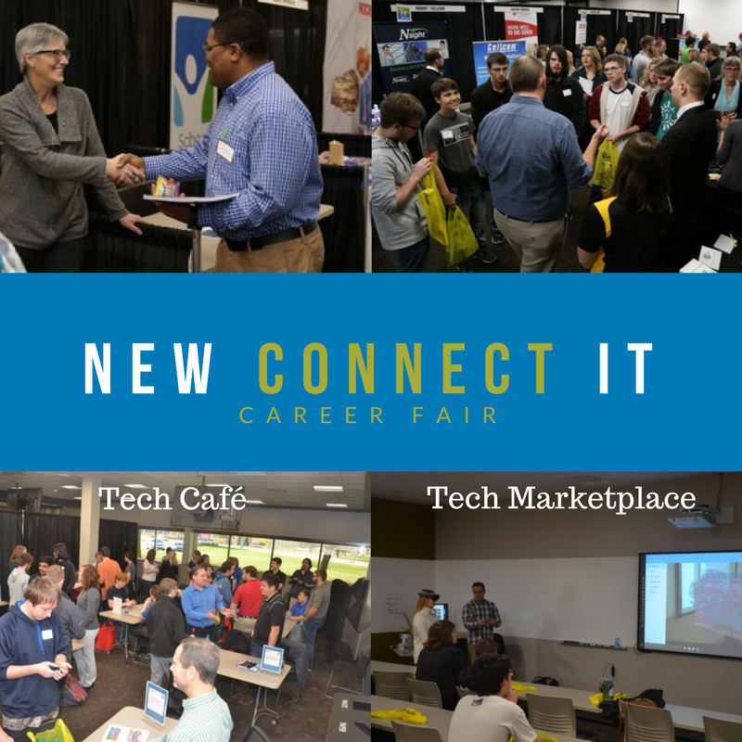  Tech Café  Tech Café allowed individuals to chat with IT professionals who were currently working in a specific IT field, and ask question’s related to what they do on a day to day basis.  Tech Marketplace  Tech Marketplace showed students what fun new technology Northeast Wisconsin companies such as KI Furniture are using today, like Virtual Reality.  Thank you to our sponsors  On behalf of the NEW IT Alliance, we would like to thank our sponsors: Stellar Blue Technologies, CESA 6, Sirius, 4imprint, IBM and NTT Data  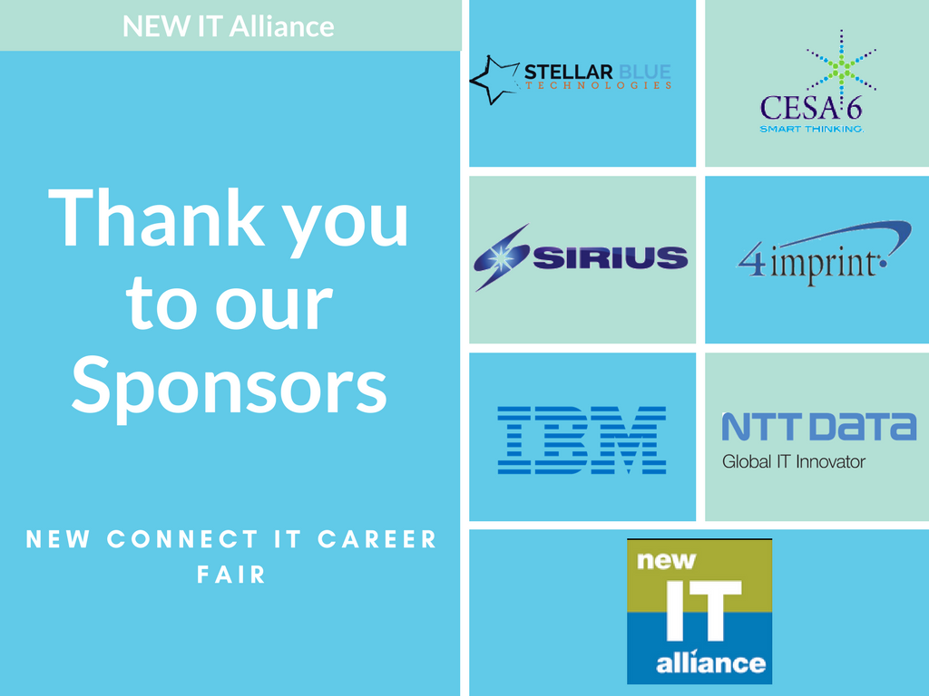  Regional News  PHUTURE PHOENIX  Recently, the University of Wisconsin-Green Bay (UWGB) Google Ignite CS project, which is part of the Center of Cyber Security Education and Outreach was host to groups of fifth graders from the Green Bay public school district brought in by the UWGB Phuture Phoenix outreach program to experience a University setting. For this event, the UWGB Google Ignite CS mentors, who are CS major students, hosted about 50 Phuture Phoenix students with the purpose of sparking an interest in computer  