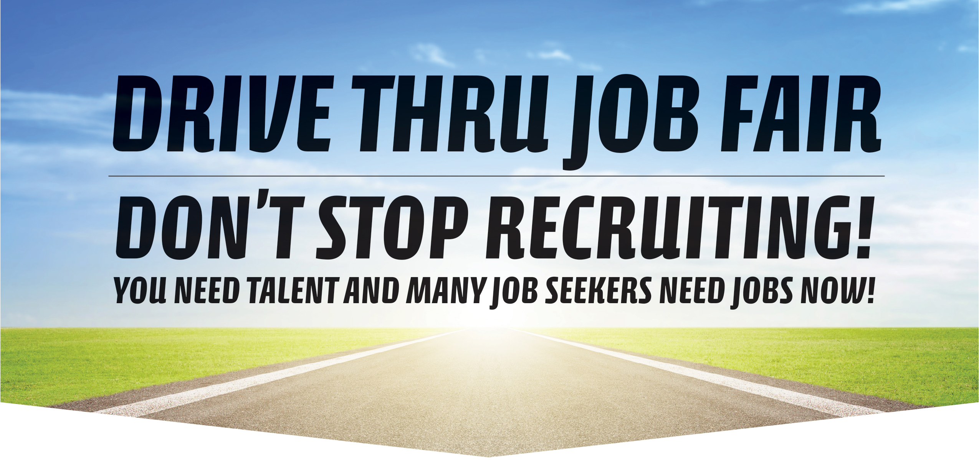

The pandemic has changed recruiting but the workforce system is still here to help you find the talent that you need! We are hosting a Drive Thru Job Fair **Sept 17** as part of a statewide, unified approach to let job seekers know that there is **still opportunity available** in their local area!

How will the fair work and how can you participate?

If you have available positions, you will need to **register at email below and provide**

**400 one-page recruitment flyers.**

**Your one page document can be printed on one or both sides, 8.5x11” or a smaller size; however, *only one page per company!* What should you include? Here are some suggestions:**

* Company name, location, logo, etc.
* Available position(s)
* How to apply
* Details about company benefits and/or wages
* What makes your company special, what is the service or product you provide?
* Include your Equal Opportunity statement
* Contact information if a job seeker would like to reach out to your company (email, phone or both)

The deadline for dropping off your information: **Noon Friday, Sept 11**

The location for dropping off information: **Forward Service Corporation Office: 726 Pine St Green Bay**

* Your one page document will be inserted into a bag
* Staff collating bags will be wearing gloves and masks
* Each car attending the drive thru fair will receive one bag of job information

To register for this event, or to learn more about other locations contact:

**Craig Coleman @** [**ccoleman@fsc-corp.org**](mailto:ccoleman@fsc-corp.org) **/ 920-940-6069**

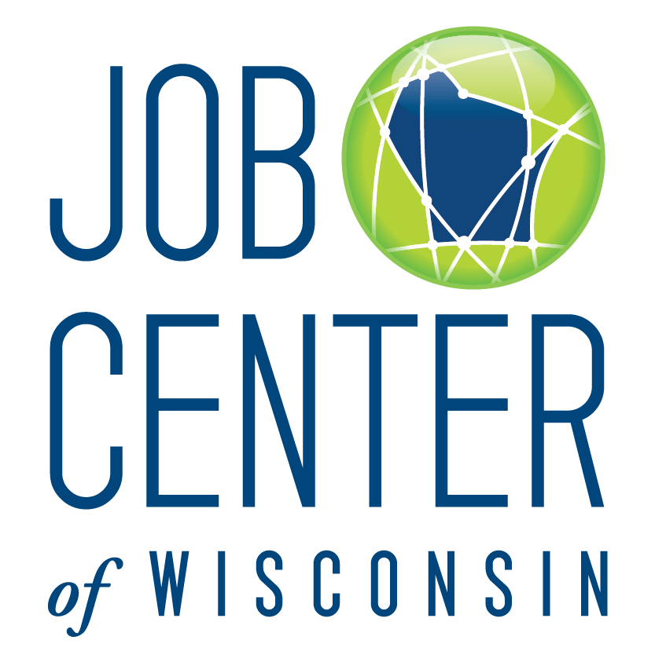

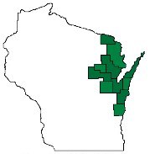

Bay Area Workforce Development Board

