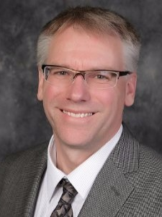
Brian Lindow, Director of Technical Services & Information Security at Secura Insurance
Brian Lindow has been a senior IT leader for 30+ years in a variety of business verticals and technologies. Verticals include the Department of Energy, Transportation/Logistics and currently with P&C Insurance. Technologies have included 20+ years as a Cybersecurity leader, infrastructure, architecture, and computer graphics. Brian’s passion is continuing to learn new technologies and leading teams through times of change and transition.

Elaine Riedel, Manager of IT Support Services at Secura Insurance
Elaine Riedel is an undergraduate of the University of Illinois with a BA in Legal Studies. After having her two children, she went on to attain her Master of Science in Management degree at Cardinal Stritch University.

Elaine initiated her career in Corporate Computer Education. She was an instructor at Illinois Central College and Moraine Park teaching computer classes for the community and companies. After several years Elaine went into the Healthcare field managing training teams at Aurora and Froedtert. Needing to be closer to her home in Fond du Lac for her kids, Elaine left the Healthcare and Education field and entered the Role of Service Desk Manager at Grande Cheese Company in 2011.

Elaine is now celebrating 5 years with SECURA Insurance in May 2021. She is the IT Manager for their IT Support Services (including the Service Desk). She manages Level 1 and Level 2 support teams and is consistently working on maturing SECURA’s IT best practices using ITIL (Information Technology Information Library) and continuing on their ITIL journey.

